Resources to explore other case studies

Inspiration is everywhere. You can get ideas for a case study to include in your portfolio from your hobbies, travels, children, volunteer work, and even something as common as waiting in line! For example, you might create a case study examining the effect of customer wait times on a company’s sales.

Let’s imagine you enjoy fishing. You can create a case study for your portfolio that relates to your hobby. It is helpful to browse Medium, GitHub, Tableau, and Kaggle to get an idea of what other people have already created and find some inspiration.

**Searching on Medium**

To search for case studies on Medium, go to [medium.com/search](https://medium.com/search).

Enter the term “fishing,”as an example. Medium will pull up a bunch of articles that are related to fishing. You can also explore topics related to fishing by clicking other tags on the right: Environment, Travel, Fishing and Travel, Outdoors, and more.

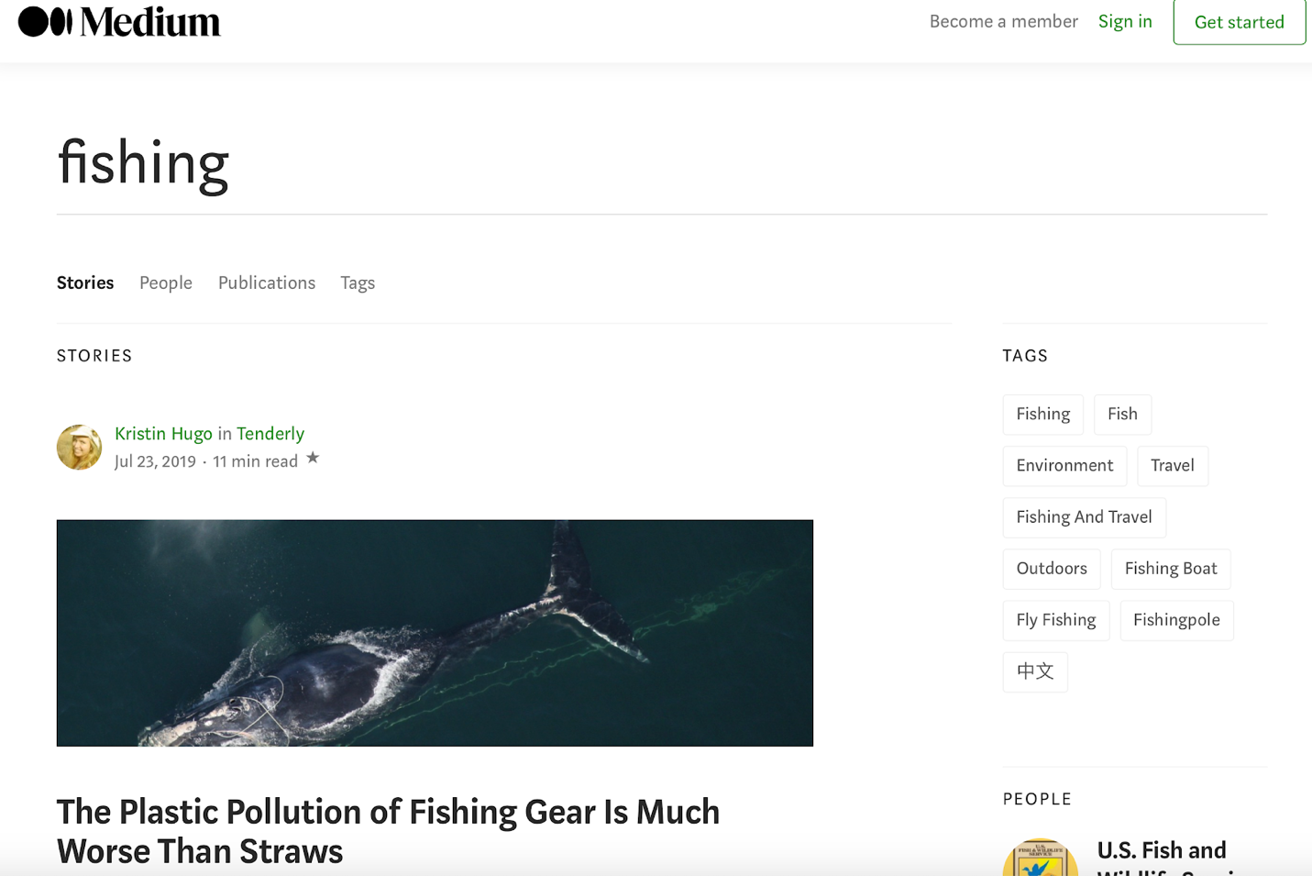

**Searching on GitHub**

To search for case studies on GitHub, go to [github.com/search](https://github.com/search).

If you enter “fishing” in the search field, GitHub returns over 4,000 results. If you enter “fishing case study” in the search field, GitHub returns one result: a case study of a marine fishing bat. Probably not a good match for you though!

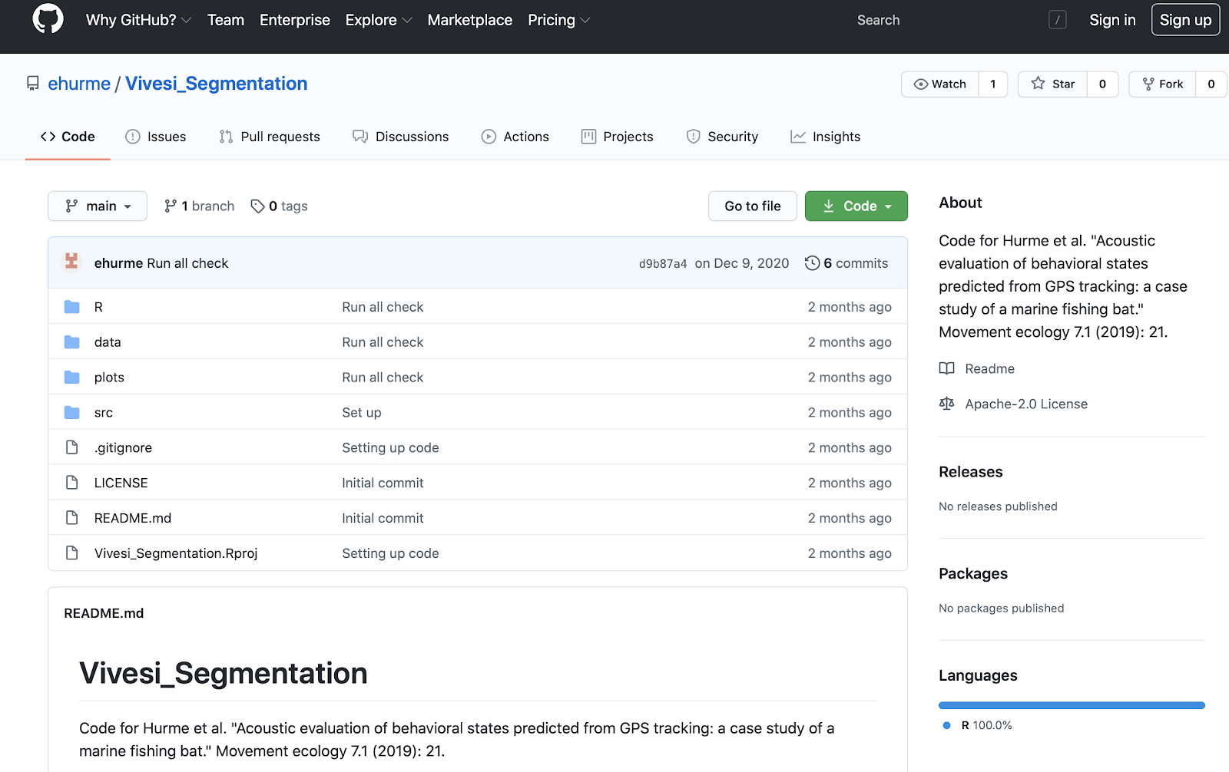

**Searching on Tableau**

To search for case studies in Tableau, go to [public.tableau.com](http://public.tableau.com) and use the search bar at the top of the page.

For example, click the search icon (the magnifying glass) and enter “fishing.” The term “fishing” returns over 400 results, but if you enter the hashtag “#fishing” instead, you get four interesting results.

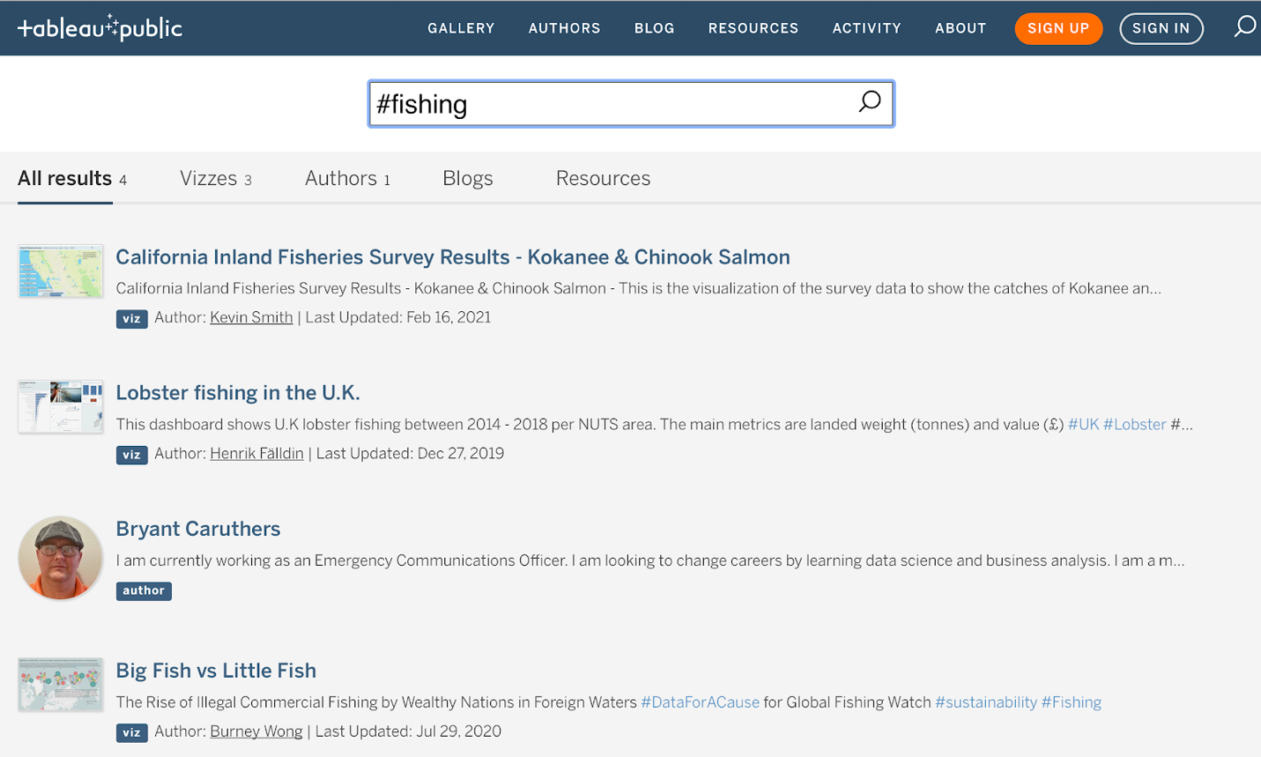

**Searching on Kaggle**

To search for case studies on Kaggle, go to [kaggle.com](https://www.kaggle.com) and use the search bar. For example, if you enter “fishing” in the search bar at the top of the page, you get results similar to the ones displayed below.

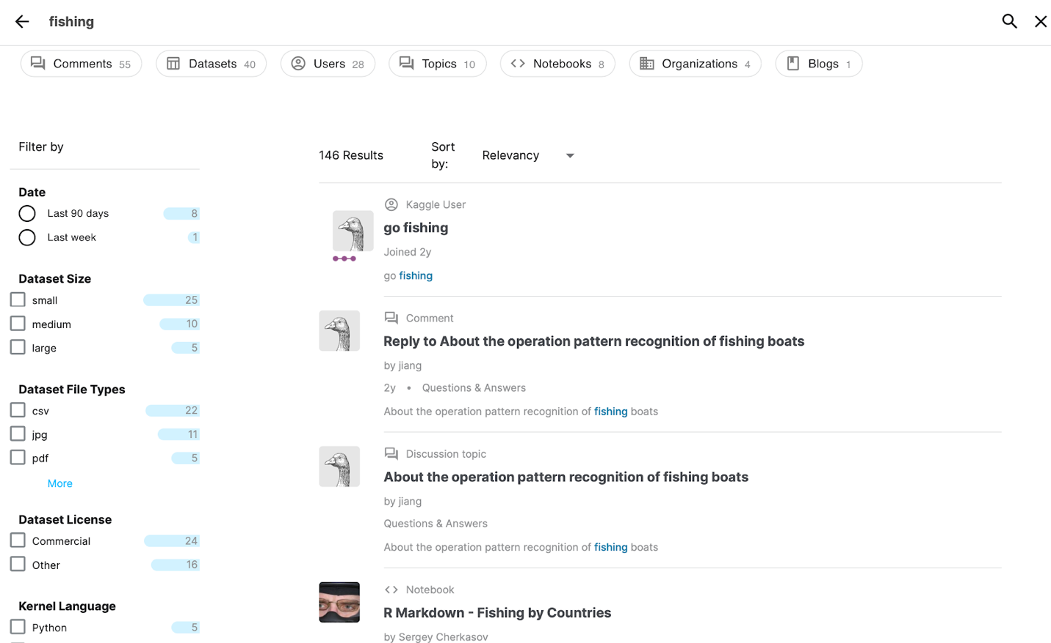

The “R Markdown - Fishing by Countries” notebook in Kaggle might be promising. You discover from this notebook that there is a public domain dataset called “Annual Nominal Fish Catches: Explore the impact of overfishing in the Northeast Atlantic region.“

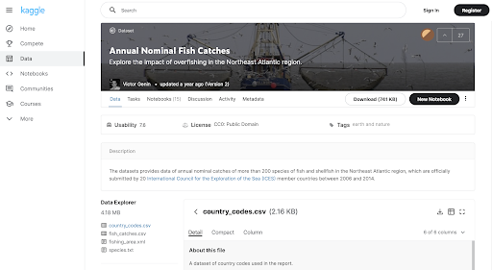

You might have just found a great dataset to use to create your own case study. You wouldn’t want to repeat the same analysis related to overfishing, but the data could reveal another pattern worth analyzing.

**Key takeaway**

You can use the same procedure completed for the fishing example to search for case studies and data about any other topic that interests you. By including case studies that are personally meaningful to you in your portfolio, you give prospective employers a better sense of the kind of person you are and what inspires your work.